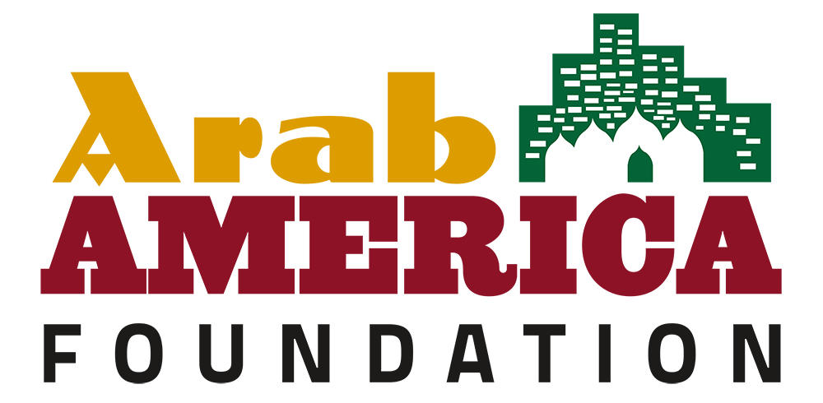

Legislative KIT Regarding Permanent Designation
of National Arab American Heritage Month in Your State

- Identify an ally in the General Assembly and approach them regarding the legislation you would like to pass.
Your legislators need to hear from you. Get to know your legislator’s staff. If you establish a relationship with your legislator, your letter or visit will have more impact than if you are a stranger.

- If your legislator agrees to take it on, write a draft of the legislation and provide it to the representative. The representative will then submit it to the official legislative drafting department, and it will be run by lawyers/experts.
Find out who supports your issue and meet with others who share your common goal. Establish a unified position. Know your opposition. It’s important to keep in mind that not everyone shares the same view. Your legislator will certainly be hearing from those that oppose your viewpoint. Understanding the opposition can be an effective tool if or when compromise is needed.

- Once the bill/resolution is submitted, it will be given a number and likely assigned a committee.
At this point, the role of the constituents is to lobby the committee members to get a vote and hopefully get it out of committee for a floor vote. Once it moves out of committee that’s when lobbying the rest of the members of the GA would begin.
Committee Hearings supporting a bill usually means phoning, writing, and, perhaps, visiting your legislator or his/her staff. You can attend hearings and testify on the bill. Ask your legislator which committee your bill has been assigned to. After a bill passes the appropriate committee, it goes to the full house. Floor sessions are open to the public; however, the debate is limited to legislators.

- Once it passes the state House, it will then be sent to the Senate for a vote after crossover.
This is when the lobbying switches from the House to the Senate. The same process is followed in the Senate. Opposition could surface in the Senate.

- If it passes both, then it essentially becomes official pending the signature of the Governor.
Let the Governor know your position. The Governor has three choices. He or she can sign the bill into law, allow it to become law without his or her signature, or veto it. A governor’s veto can be overridden by a two-thirds vote in both houses.

*This process could also vary depending on whether it’s a resolution or bill if it is sent directly to a floor vote or assigned to a committee, etc.

Sample Letter:

Date
Honorable Joe Smith
State Capitol
City, State

Dear (Representative or Senator) Smith:

I am writing to ask you to support a bill in the legislature that would designate the month of April each year as National Arab American Heritage Month (NAAHM) to be observed throughout the state of (Name of State) as a month to recognize the valuable contributions of Arab Americans to our state and to American society. To date, the States of Illinois and Oregon,
Virginia, Indiana (Senate), and California have permanently designated April as National Arab American Heritage Month in their states.

Throughout April, the Arab America Foundation formally acknowledges the accomplishments of Arab Americans. This celebration is embraced by cultural institutions, school districts, municipalities, state legislatures, public servants, and non-profit organizations nationwide. Special events and proclamations honor our community's rich heritage and contributions to American society.
The National Arab American Heritage Month initiative, launched in 2017 by Arab America and the Arab America Foundation, has gained significant momentum. Last year, our grassroots network, comprising over 250 Arab American volunteers in 26 states, secured 144 proclamations from states, counties, municipalities, and local school districts.
In 2023, the President of the United States issued a historic proclamation recognizing April as National Arab American Heritage Month. Congress, the U.S. Department of State, and 47 state governors also joined in commemorating this initiative.
We would be honored to receive a proclamation from your state, and we've provided sample language, including whereas clauses, for your convenience.

The Arab America Foundation (www.arabamericafoundation.org) is a non-profit educational and cultural organization dedicated to promoting Arab heritage in the U.S., educating Americans about Arab heritage and identity, and connecting and empowering Arab Americans.

We eagerly anticipate your positive response and appreciate your support as we commemorate National Arab American Heritage Month in April 2024.
With best wishes,

Your Name
Member, (Your State) Leadership Council
Arab America Foundation

Sample Language for Proposed Resolution or Bill
National Arab American Heritage Month

WHEREAS, for over a century, Arab Americans have been making valuable contributions to virtually every aspect of American society: in medicine, law, business, education, technology, government, military service, culture; and

WHEREAS, since migrating to America, men and women of Arab descent have shared their rich culture and traditions with neighbors and friends, while also setting fine examples of model citizens and public servants; and

WHEREAS, they brought with them to America their resilient family values, strong work ethic, dedication to education, and diversity in faith and creed that have added strength to our great democracy; and

WHEREAS, Arab Americans have also enriched our society by sharing in the entrepreneurial American spirit that makes our nation free and prosperous; and

WHEREAS, the celebration of Arab American ancestry and cultural heritage educates our fellow Americans and counters misconceptions, harmful stereotyping, and shared abuses by other ethnic groups, and

WHEREAS, they join all Americans in the desire to see a peaceful and diverse society, where every individual is treated equally and feels safe; and

WHEREAS, the incredible contributions and heritage of Arab Americans have helped us build a better nation; and

NOW, THEREFORE, it is hereby declared that the Arab America Foundation celebrates the heritage of Arab Americans and the state of ______ officially designates the month of April as National Arab American Heritage Month, to be observed throughout the state and dedicated to recognizing the valuable contributions of Arab Americans. We urge our citizens to actively participate in this special observance.
Be it enacted by the People of the State of ____, as represented in the General Assembly:

Revised: April 2024

