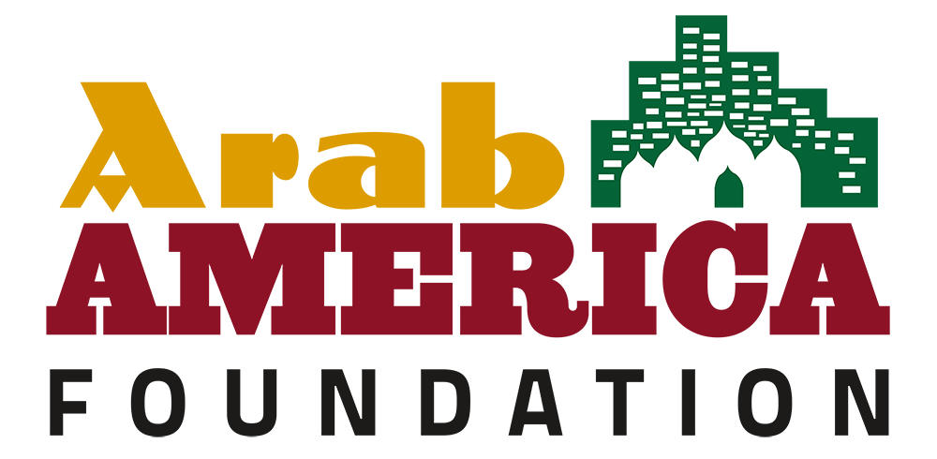

Date:
Dear [Recipient],
As a member of the National Arab American Heritage Month Committee, we invite you to recognize April 2024 as National Arab American Heritage Month.
Throughout April, the Arab America Foundation formally acknowledges the accomplishments of Arab Americans. This celebration is embraced by cultural institutions, school districts, municipalities, state legislatures, public servants, and non-profit organizations nationwide. Special events and proclamations honor our community's rich heritage and contributions to American society.
The National Arab American Heritage Month initiative, launched in 2017 by Arab America and the Arab America Foundation, has gained significant momentum. Last year, our grassroots network, comprising over 250 Arab American volunteers in 26 states, secured 144 proclamations from states, counties, municipalities, and local school districts.
In 2023, the President of the United States issued a historic proclamation recognizing April as National Arab American Heritage Month. Congress, the U.S. Department of State, and 47 state governors also joined in commemorating this initiative.
We would be honored to receive a proclamation from you, and we've provided sample language, including whereas clauses, for your convenience.
The Arab America Foundation (www.arabamericafoundation.org) is a non-profit educational and cultural organization dedicated to promoting Arab heritage in the U.S., educating Americans about Arab heritage and identity, and connecting and empowering Arab Americans.
We eagerly anticipate your positive response and appreciate your support as we commemorate National Arab American Heritage Month in April 2024.
Best wishes,

National Arab American Heritage Month Committee
Arab America Foundation

2024 Sample Proclamation
National Arab American Heritage Month

WHEREAS, for over a century, Arab Americans have been making valuable contributions to virtually every aspect of American society: in medicine, law, business, education, technology, government, military service, culture; and

WHEREAS, since migrating to America, men and women of Arab descent have shared their rich culture and traditions with neighbors and friends, while also setting fine examples of model citizens and public servants; and

WHEREAS, they brought with them to America their resilient family values, strong work ethic, dedication to education, and diversity in faith and creed that have added strength to our great democracy; and

WHEREAS, Arab Americans have also enriched our society by sharing in the entrepreneurial American spirit that makes our nation free and prosperous; and

WHEREAS, the celebration of Arab American ancestry and cultural heritage educates our fellow Americans and counters misconceptions, harmful stereotyping, and shared abuses by other ethnic groups, and

WHEREAS, they join all Americans in the desire to see a peaceful and diverse society, where every individual is treated equally and feels safe; and

WHEREAS, the incredible contributions and heritage of Arab Americans have helped us build a better nation; and

NOW, THEREFORE, we announce that the Arab America Foundation celebrates the contributions Arab Americans have made to society, and does hereby declare April 2024 to be National Arab American Heritage Month by (state, city, county, school district, organization, public servant) __________. We encourage our citizens to join us in this special observance.

Revised: April 2024

