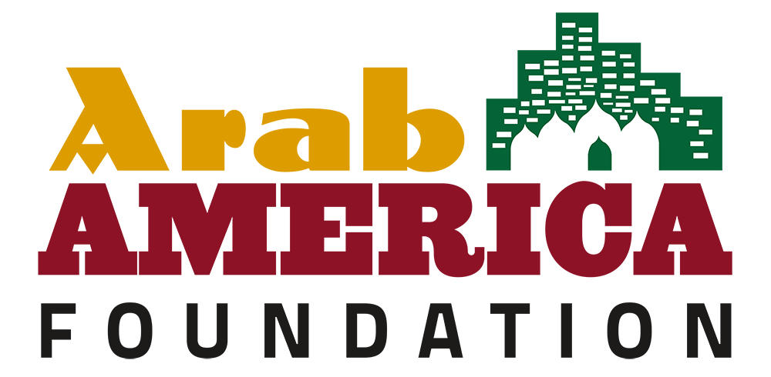

Legislative KIT Regarding Permanent Designation
of National Arab American Heritage Month in Your State

- Identify an ally in the General Assembly and approach them regarding the legislation you would like to pass.
Your legislators need to hear from you. Get to know your legislator’s staff. If you establish a relationship with your legislator, your letter or visit will have more impact than if you are a stranger.

- If your legislator agrees to take it on, write a draft of the legislation and provide it to the representative. The representative will then submit it to the official legislative drafting department, and it will be run by lawyers/experts.
Find out who supports your issue and meet with others who share your common goal. Establish a unified position. Know your opposition. It’s important to keep in mind that not everyone shares the same view. Your legislator will certainly be hearing from those that oppose your viewpoint. Understanding the opposition can be an effective tool if or when compromise is needed.

- Once the bill/resolution is submitted, it will be given a number and likely assigned a committee.
At this point, the role of the constituents is to lobby the committee members to get a vote and hopefully get it out of committee for a floor vote. Once it moves out of committee that’s when lobbying the rest of the members of the GA would begin.
Committee Hearings supporting a bill usually means phoning, writing, and, perhaps, visiting your legislator or his/her staff. You can attend hearings and testify on the bill. Ask your legislator which committee your bill has been assigned to. After a bill passes the appropriate committee, it goes to the full house. Floor sessions are open to the public; however, the debate is limited to legislators.

- Once it passes the state House, it will then be sent to the Senate for a vote after crossover.
This is when the lobbying switches from the House to the Senate. The same process is followed in the Senate. Opposition could surface in the Senate.

- If it passes both, then it essentially becomes official pending signature of the Governor.
Let the Governor know your position. The Governor has three choices. He or she can sign the bill into law, allow it to become law without his or her signature, or veto it. A governor’s veto can be overridden by a two-thirds vote in both houses.

*This process could also vary depending on whether it’s a resolution or bill, if it is sent directly to a floor vote or assigned a committee, etc.

Sample Letter:

Date
Honorable Joe Smith
State Capitol
City, State

Dear (Representative or Senator) Smith:

I am writing to ask you to support a bill in the legislature which would designate the month of April each year as National Arab American Heritage Month (NAAHM) to be observed throughout the state of (Name of State) as a month to recognize the valuable contributions of Arab Americans to our state and to American society. To date, the States of Illinois and Oregon, and Virginia have designated National Arab American Heritage Month permanently through legislation.

During the month of April, the Arab America Foundation formally recognizes the achievements of Arab Americans through the celebration of National Arab American Heritage Month. Across the country, cultural institutions, school districts, municipalities, state legislatures, public servants, and non-profit organizations issue proclamations and engage in special events that celebrate our community’s rich heritage and numerous contributions to society.

Arab America and the Arab America Foundation launched the National Arab American Heritage Month initiative in 2017, with just a handful of states recognizing the initiative. This year, our grass-roots network of over 250 Arab American volunteers in 28 states gathered is gathering proclamations from their states, counties, municipalities, and local school districts.

The President of the United States recognized the month of April 2023 as National Arab American Heritage Month with a historic proclamation as well as Congress, and the U.S. Department of State. Last year, 45 state governors issued proclamations commemorating the initiative, our goal is to reach 50 this year.

We would be honored to receive a proclamation from you. I have provided sample language, including whereas clauses for the proclamation if that would be helpful.

The Arab America Foundation (www.arabamericafoundation.org) is a non-profit educational and cultural organization that promotes the Arab heritage in the U.S., educates Americans about the Arab heritage and identity, and connects and empowers Arab Americans.

Again, we look forward to hearing from you soon and thank you in advance for supporting us as we commemorate National Arab American Heritage Month in April 2023.

With best wishes,

Your Name
Member, (Your State) Leadership Council
Arab America Foundation

Sample Language for Proposed Resolution or Bill
National Arab American Heritage Month

WHEREAS, for over a century, Arab Americans have been making valuable contributions to virtually every aspect of American society: in medicine, law, business, education, technology, government, military service, culture; and

WHEREAS, since migrating to America, men and women of Arab descent have shared their rich culture and traditions with neighbors and friends, while also setting fine examples of model citizens and public servants; and

WHEREAS, they brought with them to America their resilient family values, strong work ethic, dedication to education, and diversity in faith and creed that have added strength to our great democracy; and

WHEREAS, Arab Americans have also enriched our society by sharing in the entrepreneurial American spirit that makes our nation free and prosperous; and

WHEREAS, the history of Arab Americans in the US. remains neglected or defaced by misconceptions, bigotry, and anti-Arab hate in the forms of crimes and speech; and

WHEREAS, Arab American issues, such as civil rights abuses, harmful stereotyping, and bullying must be combated in the forms of education and awareness; and

WHEREAS, they join all Americans in the desire to see a peaceful and diverse society, where every individual is treated equally and feels safe; and

WHEREAS, the incredible contributions and heritage of Arab Americans have helped us build a better nation; and

WHEREAS, We recognize and celebrate the contributions to cultural diversity, economic growth, and the overall development of our State and nation made by the Arab American
community; therefore

Be it enacted by the People of the State of _____, represented in the General Assembly:

Arab American Heritage Month. The month of April of each year is designated as Arab American Heritage Month to be observed throughout the State as a month to recognize the valuable contributions of Arab Americans to this State and to the various aspects of American society.

Updated: April 2023

