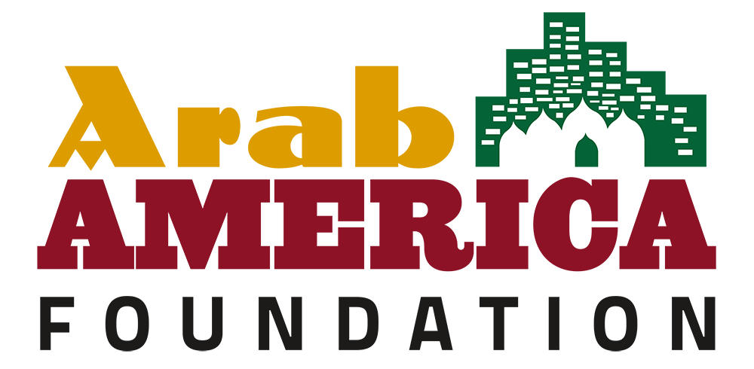

Legislative KIT Regarding Permanent Designation
of National Arab American Heritage Month in Your State

- Identify an ally in the General Assembly and approach them regarding the legislation you would like to pass.
Your legislators need to hear from you. Get to know your legislator’s staff. If you establish a relationship with your legislator, your letter or visit will have more impact than if you are a stranger.

- If your legislator agrees to take it on, write a draft of the legislation and provide it to the representative. The representative will then submit it to the official legislative drafting department, and it will be run by lawyers/experts.
Find out who supports your issue and meet with others who share your common goal. Establish a unified position. Know your opposition. It’s important to keep in mind that not everyone shares the same view. Your legislator will certainly be hearing from those that oppose your viewpoint. Understanding the opposition can be an effective tool if or when compromise is needed.

- Once the bill/resolution is submitted, it will be given a number and likely assigned a committee.
At this point, the role of the constituents is to lobby the committee members to get a vote and hopefully get it out of committee for a floor vote. Once it moves out of committee that’s when lobbying the rest of the members of the GA would begin.
Committee Hearings supporting a bill usually means phoning, writing, and, perhaps, visiting your legislator or his/her staff. You can attend hearings and testify on the bill. Ask your legislator which committee your bill has been assigned to. After a bill passes the appropriate committee, it goes to the full house. Floor sessions are open to the public; however, the debate is limited to legislators.

- Once it passes the state House, it will then be sent to the Senate for a vote after crossover.
This is when the lobbying switches from the House to the Senate. The same process is followed in the Senate. Opposition could surface in the Senate.

- If it passes both, then it essentially becomes official pending signature of the Governor.
Let the Governor know your position. The Governor has three choices. He or she can sign the bill into law, allow it to become law without his or her signature, or veto it. A governor’s veto can be overridden by a two-thirds vote in both houses.

*This process could also vary depending on whether it’s a resolution or bill, if it is sent directly to a floor vote or assigned a committee, etc.

Sample Letter:

January 10, 2022
Honorable Joe Smith
State Capitol
City, State

Dear (Representative or Senator) Smith:

I am writing to ask you to support a bill in the legislature which would designate the month of April each year as National Arab American Heritage Month (NAAHM) to be observed throughout the state of (Name of State) as a month to recognize the valuable contributions of Arab Americans to our state and to American society. To date, the States of Illinois and Oregon have designated National Arab American Heritage Month permanently through legislation.

During the month of April, the Arab America Foundation formally recognizes the achievements of Arab Americans through the celebration of National Arab American Heritage Month. Across the country, cultural institutions, school districts, municipalities, state legislatures, non-profit organizations, and public servants, engage in special events that celebrate our community’s rich heritage and numerous contributions to society.

Arab America and the Arab America Foundation launched the National Arab American Heritage Month initiative in 2017, with just a handful of states recognizing the initiative. Last year, our grass-roots network of over 250 Arab American volunteers in 26 states gathered proclamations from their states, counties, municipalities, local school districts, and public servants.

In fact, the President of the United States recognized the month of April as National Arab American Heritage Month with a special letter to our organization. Additionally, Congress, the U.S. Department of State, 130 proclamations, and 37 state governors issued proclamations commemorating the initiative.

The Arab America Foundation (www.arabamericafoundation.org) is a non-profit educational and cultural organization that promotes the Arab heritage in the U.S., educates Americans about the Arab heritage and identity, and connects and empowers Arab Americans.

We welcome your support to this initiative and thank you for your consideration of our request and look forward to hearing from you at your earliest convenience.

Your Name
Member, (Your State) Leadership Council
Arab America Foundation

Sample Language for Proposed Resolution or Bill
National Arab American Heritage Month

WHEREAS, It is appropriate and right to celebrate a diversity of cultures and heritages, and such celebration serves as a reminder that despite our differing backgrounds, everyone in ____ is bound by a common hope for a better and more inclusive future for our children; and

WHEREAS, The Arab American community has a long and integral history in the United States; and

WHEREAS, For over a century, Arab Americans have been making valuable contributions to virtually every aspect of American society, including medicine, law, business, technology, government, and culture; and

WHEREAS, since migrating to America, men and women of Arab descent have shared their rich culture and traditions with neighbors and friends, while also setting fine examples of model citizens and public servants; and

WHEREAS, they brought with them to America their resilient family values, strong work ethic, dedication to education, and diversity in faith and creed that have added strength to our great democracy; and

WHEREAS, Arab Americans have also enriched our society by sharing in the entrepreneurial American spirit that makes our nation free and prosperous; and

WHEREAS, Tens of thousands of Arab Americans have served during World War I, World War II, the Korean War, Vietnam War, the Iraq War, and the Wars in Afghanistan and Iraq after
September 11, 2001; and

WHEREAS, The history of Arab Americans in the US. remains neglected or defaced by misconceptions, bigotry, and anti-Arab hate in the forms of crimes and speech; and

WHEREAS, Men and women of Arab descent have shared their rich culture, strong work ethic, and dedication to education while embracing the American spirit of opportunity and helping us build a better nation and State for all; and

WHEREAS, It is estimated that there are approximately___ people of Arab American descent in (State) with more than ___ Arab American voters registered; and

WHEREAS, We recognize and celebrate the contributions to cultural diversity, economic growth, and the overall development of our State and nation made by the Arab American
community; therefore

Be it enacted by the People of the State of _____, represented in the General Assembly:

Arab American Heritage Month. The month of April of each year is designated as Arab American Heritage Month to be observed throughout the State as a month to recognize the valuable contributions of Arab Americans to this State and to the various aspects of American society.

