2022 Letter and Proclamation Kit
for School Districts, Municipal, County, State Officials,
and Non-Profit Organizations

Sample Letter:

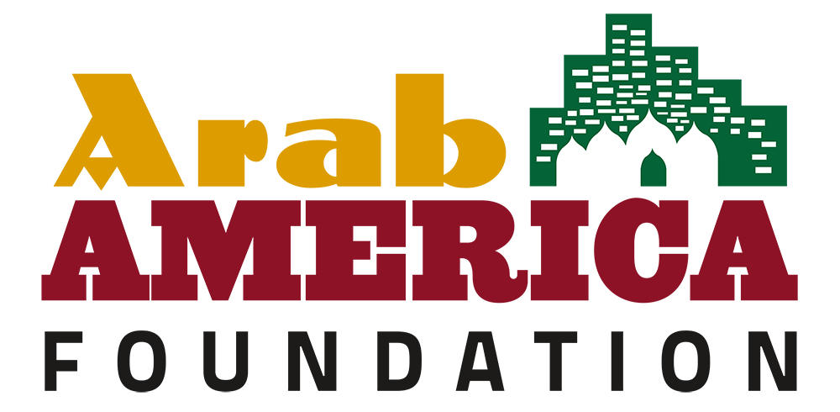

Date:

Dear_________,

As a member of the National Arab American Heritage Month Committee, I would like to invite you to recognize April 2022 as National Arab American Heritage Month.

During the month of April, the Arab America Foundation formally recognizes the achievements of Arab Americans through the celebration of National Arab American Heritage Month. Across the country, cultural institutions, school districts, municipalities, state legislatures, public servants, and non-profit organizations issue proclamations and engage in special events that celebrate our community’s rich heritage and numerous contributions to society.

Arab America and the Arab America Foundation launched the National Arab American Heritage Month initiative in 2017, with just a handful of states recognizing the initiative. Last year, our grass-roots network of over 250 Arab American volunteers in 26 states gathered 130 proclamations from their states, counties, municipalities, and local school districts.

In fact, the President of the United States recognized the month of April as National Arab American Heritage Month with a special letter to our organization. Additionally, Congress, the U.S. Department of State, and 37 state governors issued proclamations commemorating the initiative.

We would be honored to receive a proclamation from you. I have provided sample language, including whereas clauses for the proclamation if that would be helpful.

The Arab America Foundation (www.arabamericafoundation.org) is a non-profit educational and cultural organization that promotes the Arab heritage in the U.S., educates Americans about the Arab heritage and identity, and connects and empowers Arab Americans.

Again, we look forward to hearing from you soon and thank you in advance for supporting us as we commemorate National Arab American Heritage Month in April 2022.

With best wishes,

(Your Name)
Member,
National Arab American Heritage Month Committee
Arab America Foundation

2022 Sample Proclamation
National Arab American Heritage Month

WHEREAS, for over a century, Arab Americans have been making valuable contributions to virtually every aspect of American society: in medicine, law, business, education, technology, government, military service, culture; and

WHEREAS, since migrating to America, men and women of Arab descent have shared their rich culture and traditions with neighbors and friends, while also setting fine examples of model citizens and public servants; and

WHEREAS, they brought with them to America their resilient family values, strong work ethic, dedication to education, and diversity in faith and creed that have added strength to our great democracy; and

WHEREAS, Arab Americans have also enriched our society by sharing in the entrepreneurial American spirit that makes our nation free and prosperous; and

WHEREAS, the history of Arab Americans in the US. remains neglected or defaced by misconceptions, bigotry, and anti-Arab hate in the forms of crimes and speech; and

WHEREAS, Arab American issues, such as civil rights abuses, harmful stereotyping, and bullying must be combated in the forms of education and awareness; and

WHEREAS, they join all Americans in the desire to see a peaceful and diverse society, where every individual is treated equally and feels safe; and

WHEREAS, the incredible contributions and heritage of Arab Americans have helped us build a better nation; and

NOW, THEREFORE, we announce that the Arab America Foundation celebrates the contributions Arab Americans have made to society, and does hereby declare April 2022 to be National Arab American Heritage Month by (state, city, county, school district, organization, public servant) __________. We encourage our citizens to join us in this special observance

